Plotting Standard Curves in MS Excel

Table of Contents

1. Standard curve for estimation of glucose concentration 2

2. Standard curve for estimation of protein concentration 6

- The objectives of this practical are to:
- Create a formula to calculate the average of a set of data.
- Plot standard curves in MS Excel.
- Fit a linear trendline to a set of data plotted on a graph.
- Use the R² value to evaluate the correlation in a set of data.
- Use a standard curve and its equation of the line to determine the concentration of a reagent in unknown samples.
- Format graphs as appropriate for a laboratory report.

Standard curve for estimation of glucose concentration

The amount (i.e. concentration) of glucose in a solution can be estimated using a spectrophotometer. The results of such an experiment are shown in the table below.

Your task is to estimate the amount of glucose in the unknown sample by plotting a standard curve.

Glucose  (mg/ ml) | 10 | 25 | 40 | 50 | 75 | 100 | unknown
Absorbance  @ 540 nm | 0.047 | 0.115 | 0.185 | 0.231 | 0.356 | 0.480 | 0.174

Plot the standard curve
- Enter the data from the table into a worksheet in MS Excel:
- You will need to enter the data into two columns – one for Glucose and one for Absorbance.
- Use the mouse to highlight the data for the six Glucose standards (10 – 100 mg/ml) and their corresponding Absorbance values.
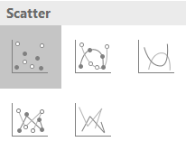
- When the data has been selected, from the Insert tab under the Charts group, click on the type of chart you wish to plot.
- From the selection of Scatter chart types, choose the Scatter (i.e. with only markers) option from the drop-down menu:
- As a standard curve, a.k.a. calibration curve is being plotted (as in this case) do not select a chart type that ‘joins the dots’.
- Instead select the Scatter graph option as shown.

Format the graph
- Add labels to the x- and y-axes of the graph:
- Don’t forget to include the units, which should be listed in parentheses after the label, e.g. Glucose (mg/ml)
- Add a short descriptive chart title above the graph:
- Note: A descriptive title does not mean that you repeat the labels on the x- and y-axes with a V or VS between them.
- Think about the data that you have plotted and come up with something more descriptive.
- Select the horizontal gridlines button on the graph and delete them. Repeat to delete the vertical gridlines:
- Gridlines are only used to read heights from bar/column charts, and are not needed on scatter graphs.
- Include tick marks on the x- and y-axes at all the major unit points on the axes:
- Right click on the x-axis and select the Format Axis menu option.
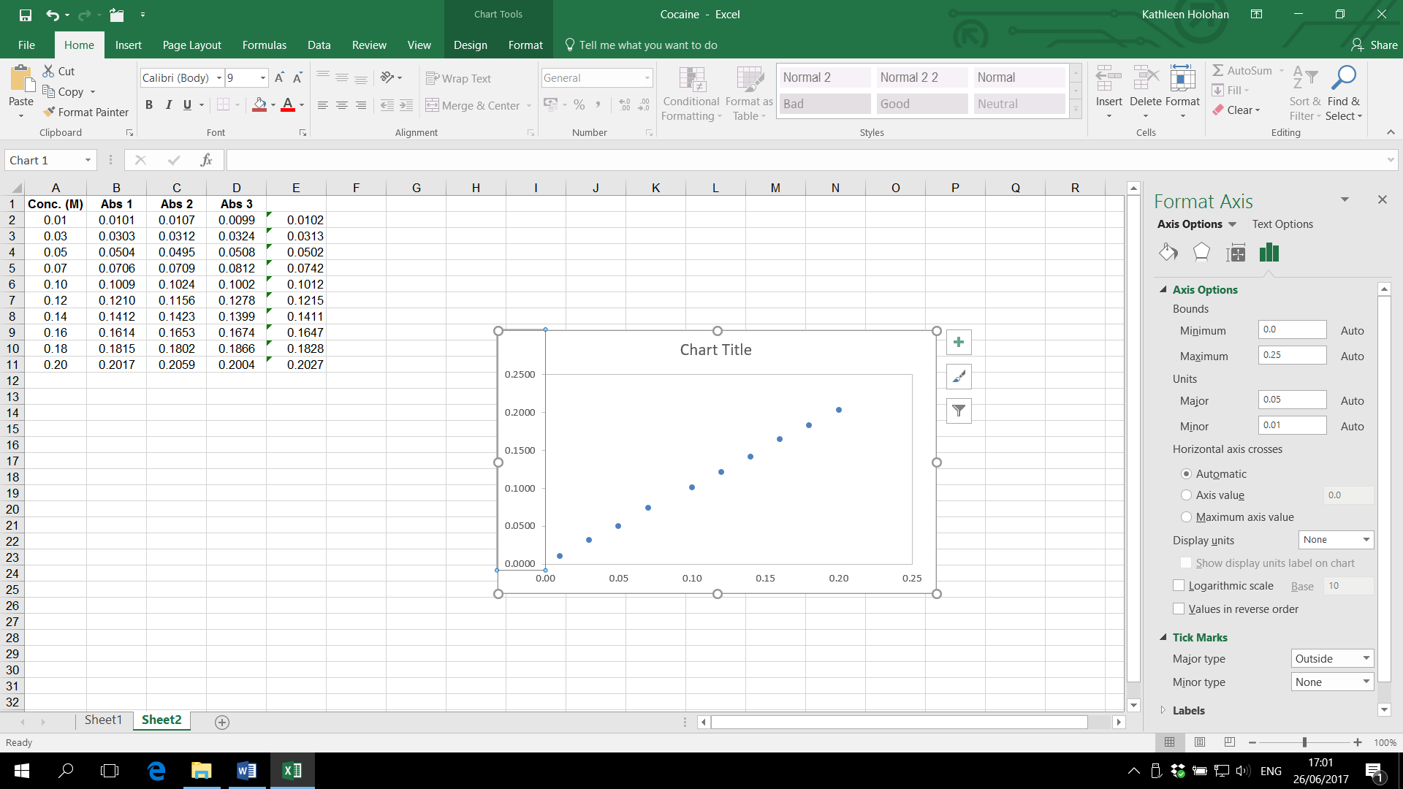

- From the Format Axis dialog box, scroll down to the Tick Marks options. Set the Major type to Outside.
- Note: there is no need to show the Minor type tick marks, unless a value is being read from a graph. If this were the case then set the Major tick mark type to Cross and the Minor tick mark type to Outside.
- Repeat this process to insert major tick marks outside the y-axis.

Fit a linear trendline to the data points
The trendline is the line of best fit to the data points it is the best visual description of the relationship between the variables plotted on the x-axis and y-axis.

- Select the data points on the graph by clicking on any point plotted.
- From the Chart Tools Design tab, select Add Chart Element and then select Trendline tool, and then More Trendline Options.
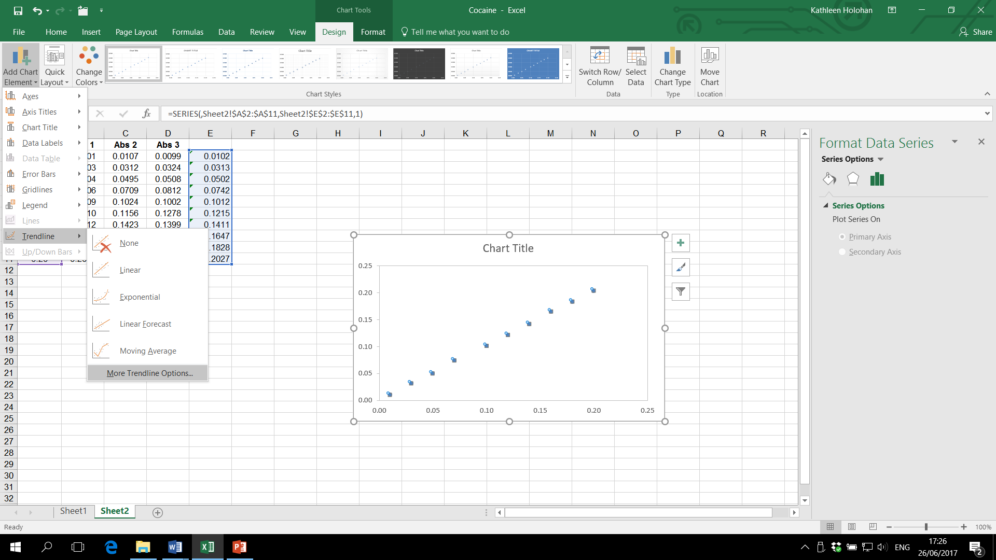

- From the Format Trendline dialog box, select the Linear Trendline Option. Place a tick in the boxes to:
- Display Equation on chart
- Display R-squared value on chart
The equation of the trendline is needed if the graph is to be used as a standard curve to work out unknown values. For a linear trendline, the following equation applies:
y = mx + c
where m is the slope of the trendline, and c is the intercept of the trendline with the y-axis.
The R² value is a numerical measure of correlation in the data, and is used to determine whether or not there is in fact a linear relationship between the variables plotted on the x- and y-axes. The closer the R² value is to 1, the greater the degree of correlation there is between these variables.

Use the standard curve to determine unknown values
The standard curve will now be used to determine the concentration of glucose in the unknown sample.
- Type the words Slope and Intercept into two blank cells on the worksheet, and then enter the values for the slope and intercept given on the trendline into the adjacent cells.
- Enter a formula into another cell of the worksheet that will calculate the glucose concentration of the sample from the slope and intercept values:
- I.e. Use the cells containing the Slope (m), Intercept (c) and sample Absorbance (y) to work out the unknown sample Concentration (x).
- Use the Decrease decimal tool on the Number group of the Home tab, to reduce the number of significant figures in the calculated answer to none (i.e. report the glucose value as a whole number):
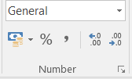
- Note: When reporting results from calculations carried out in Excel (or a calculator) it is wrong to use all the significant figures given. This implies greater experimental precision than is known. Always use the same number of significant figures as was given in the original data.

Standard curve for estimation of protein concentration

The results of an experiment to measure the concentration of protein in a sample solution using a UV spectrophotometer are shown in the table below. Six standards of increasing concentration of the protein were prepared (covering the range 20 – 120 μg/ml), and their optical density (OD) values measured.

- Estimate the concentration of protein in the unknown sample by plotting and using a standard curve of the data.

Protein concentration (μg/ml) | OD @ 280 nm
Protein concentration (μg/ml) | Actual reading | X 10³
20 | 0.00270
40 | 0.00357
60 | 0.00513
80 | 0.00645
100 | 0.00800
120 | 0.00909
Unknown | 0.00750

- Note: If you prefer dealing with whole numbers you could convert the readings by multiplying by a factor of 103. This would need to be noted in the y-axis title.

